PRUEBAS UNITARIAS ENDPOINTS BACKEND

1.- POST: http://localhost:8080/api/register

{
"name": "Admin Usuario",
"email": "admin@biblioteca.com",
"password": "password123",
"password_confirmation": "password123"
}

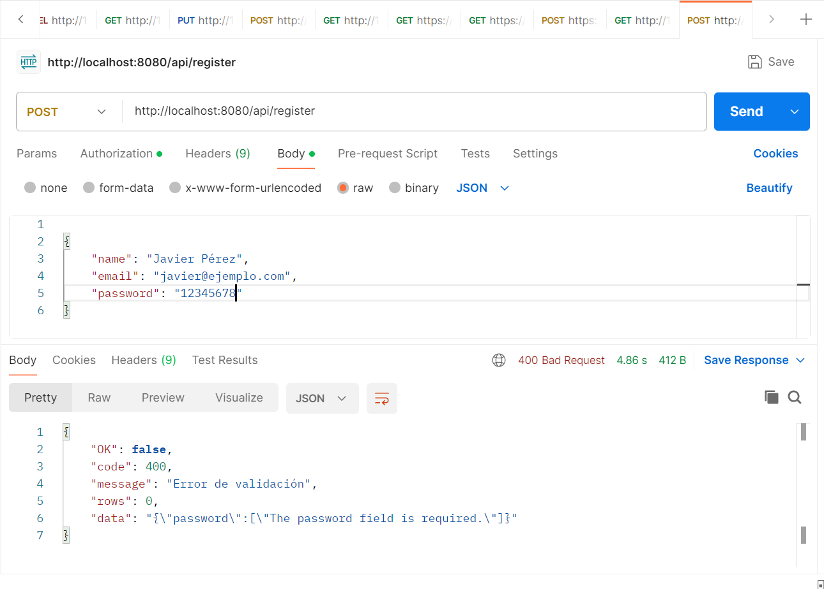
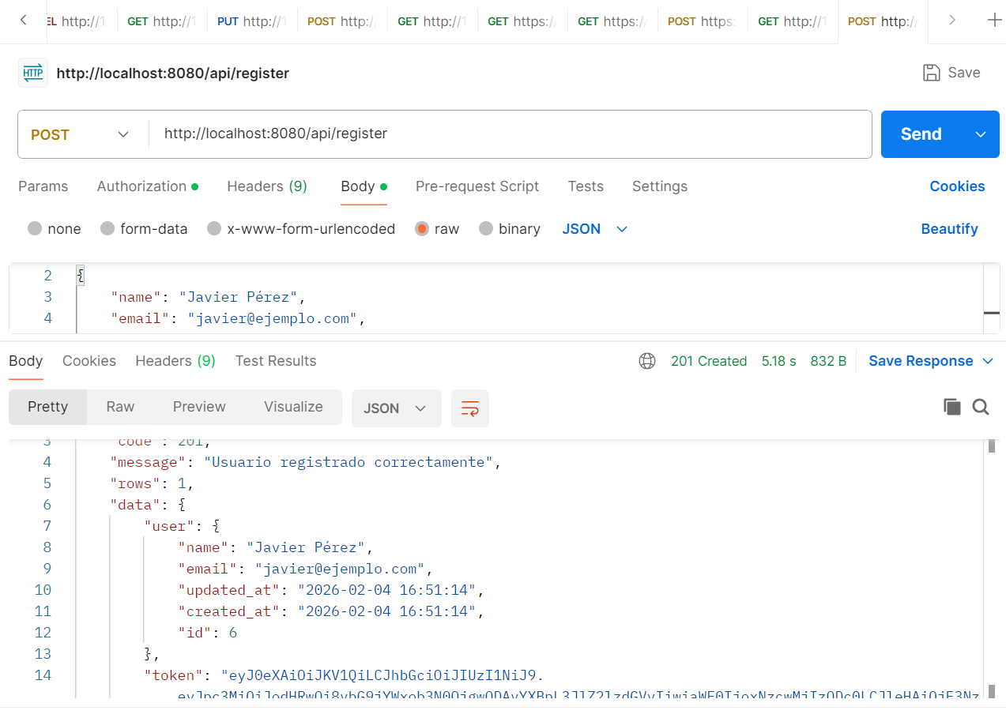

2.- POST: http://localhost:8080/api/login

{
"email": "javier@gmail.com",
"password": "12345678",
"password_confirm": "12345678"
}

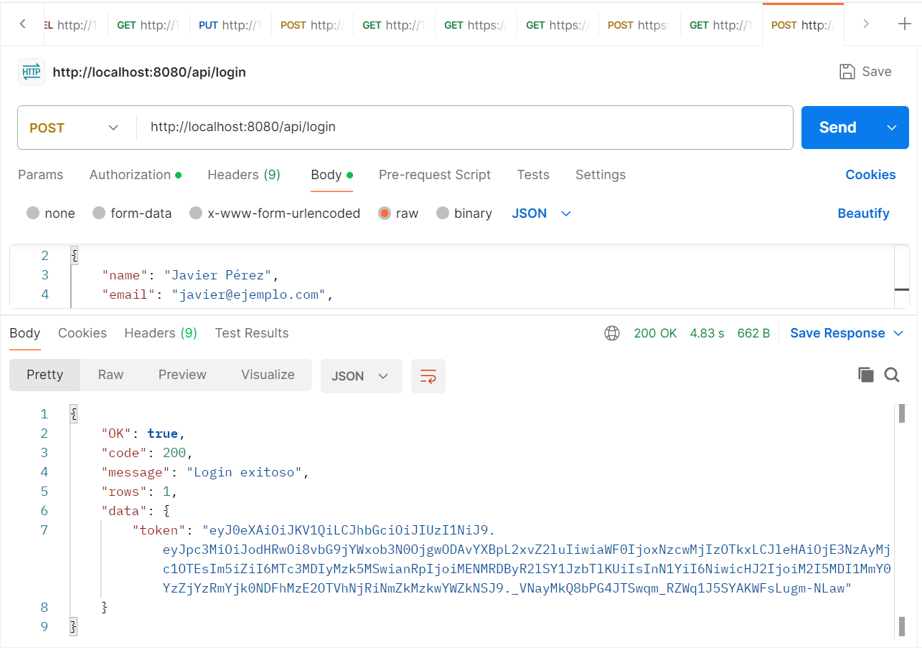

3.- POST: http://localhost:8080/api/authors
{
"name": "Javier Rodriguez",
"nationality": "Venezolano",
"birth_date": "1984-25-06"
}

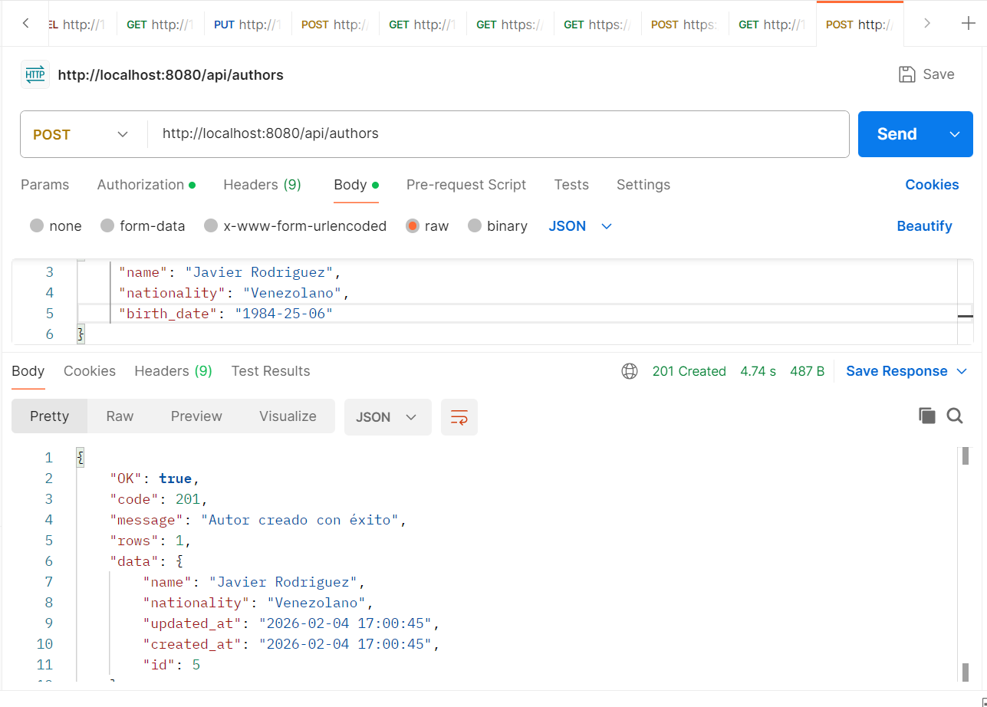

4.- GET: http://localhost:8080/api/authors

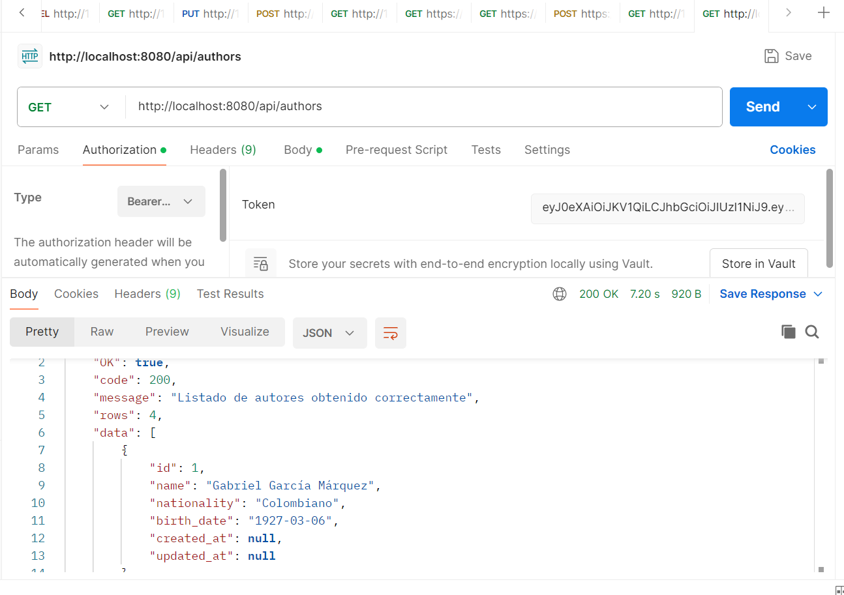

5.- http://localhost:8080/api/authors/1
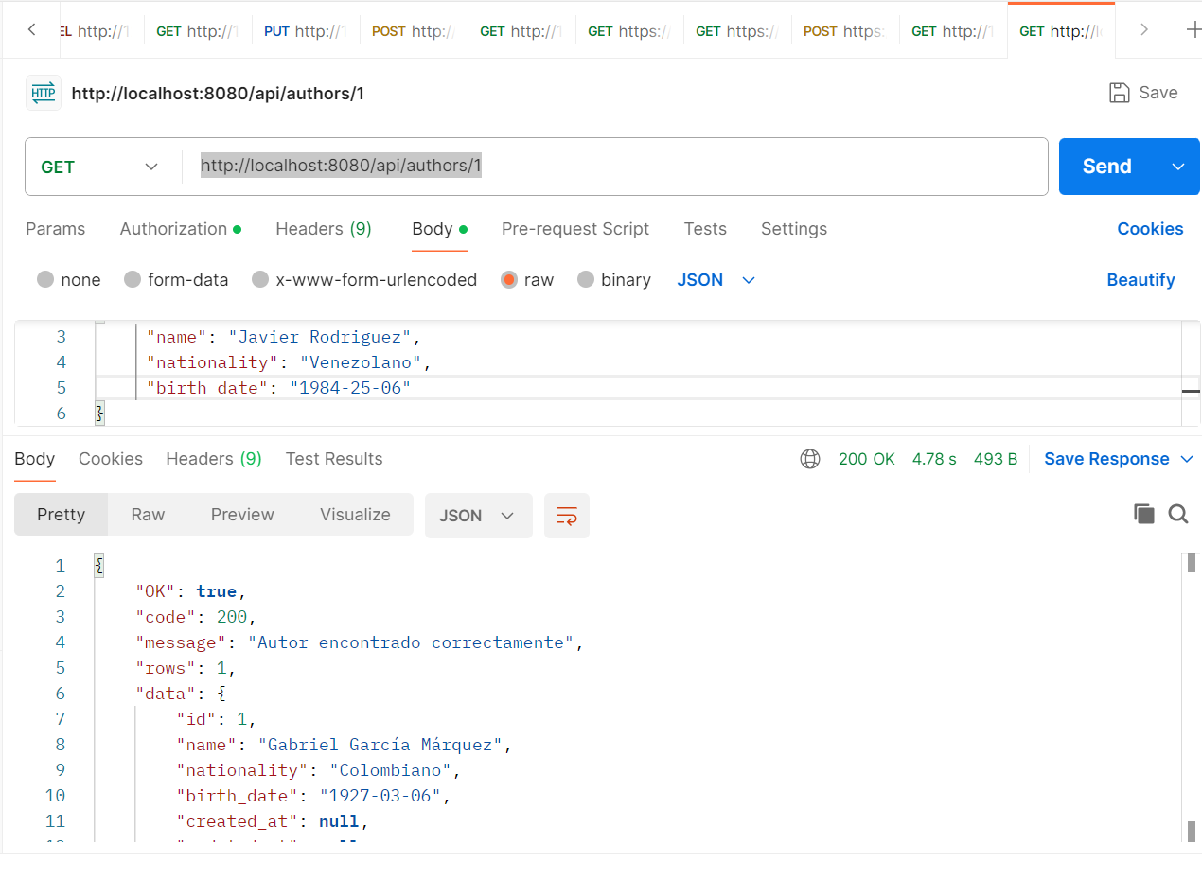

6.- PUT: http://localhost:8080/api/authors/1

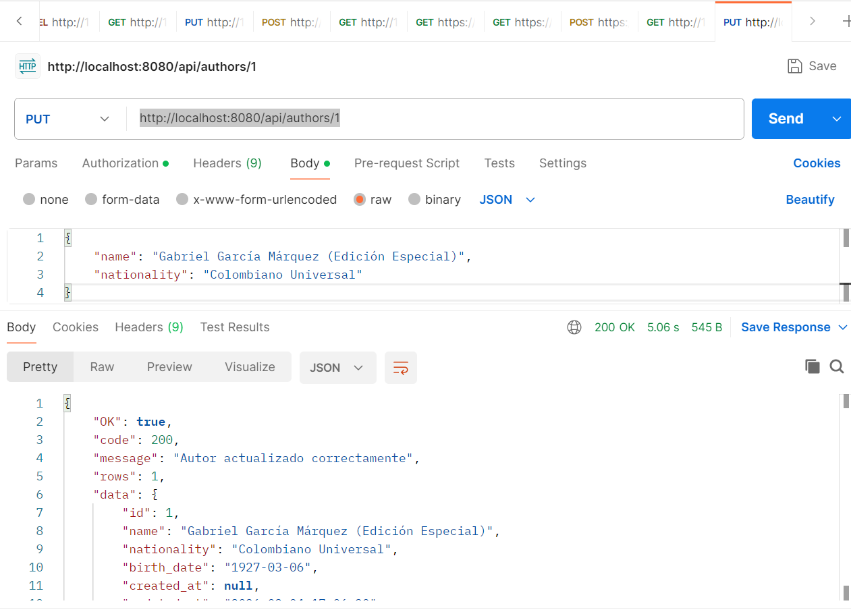

7.- DELETE: http://localhost:8080/api/authors/3

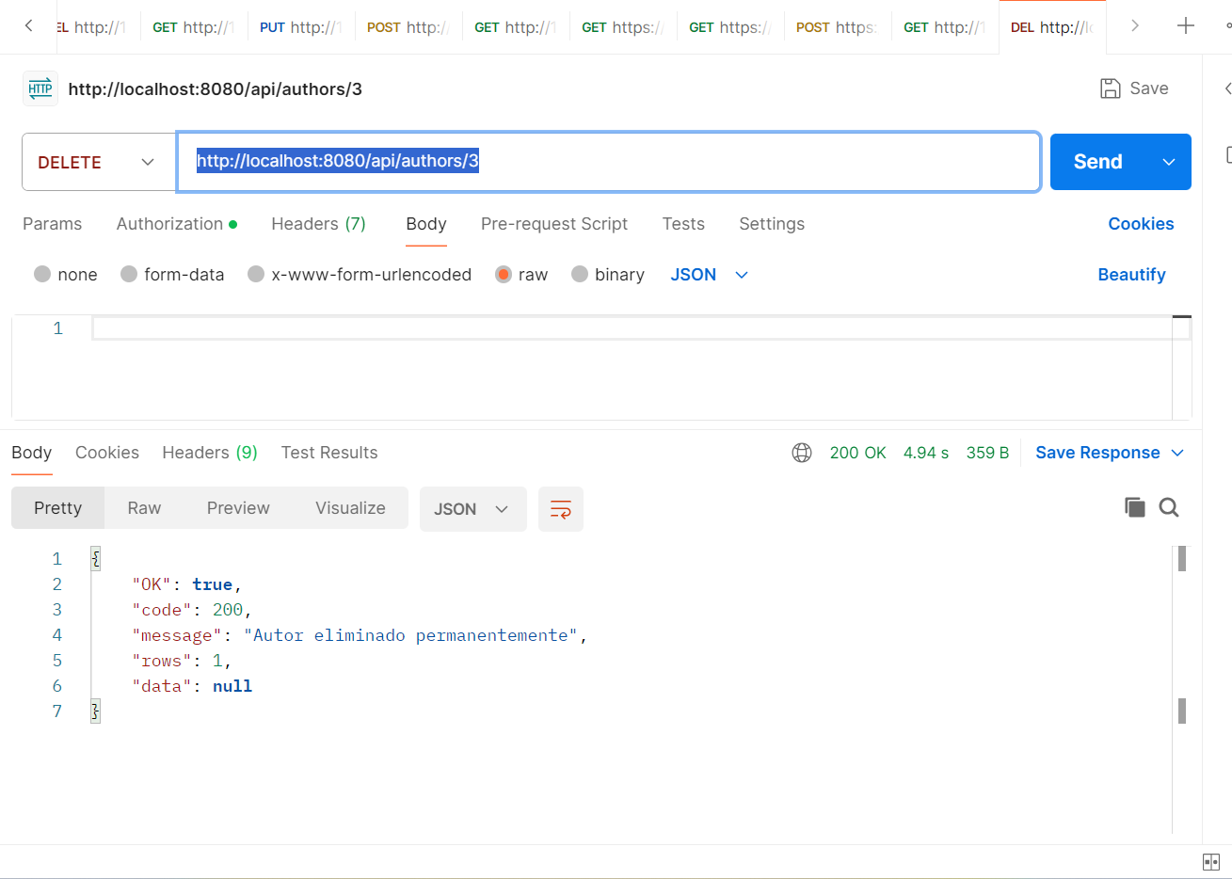

8.- GET: http://localhost:8080/api/books

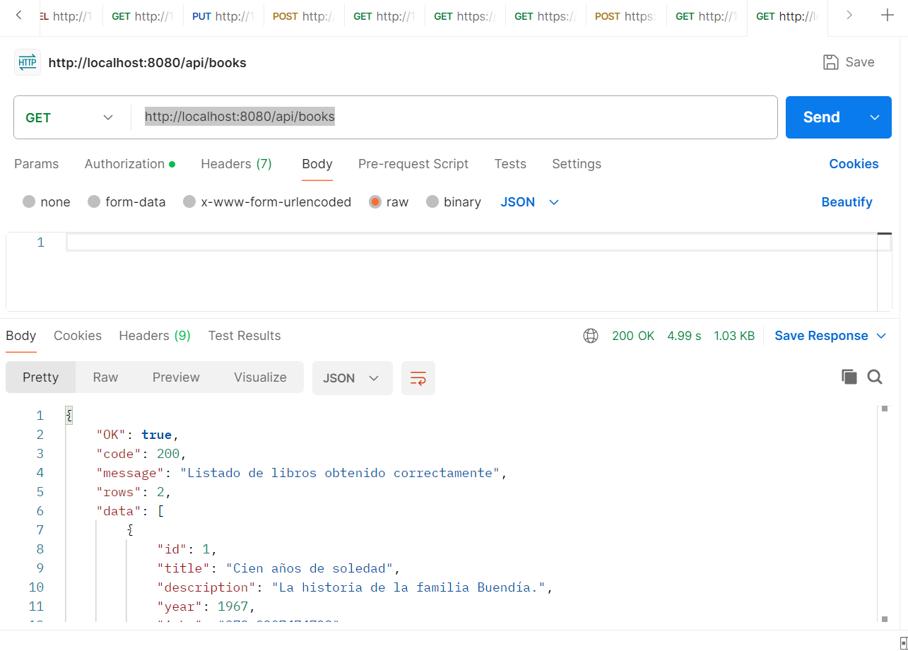
9.- POST: http://localhost:8080/api/books

{
"title": "Cien años de soledad",
"description": "Una de las obras más importantes de la literatura hispana.",
"author_id": 1,
"year": 1967,
"isbn": "978-0307474728"
}

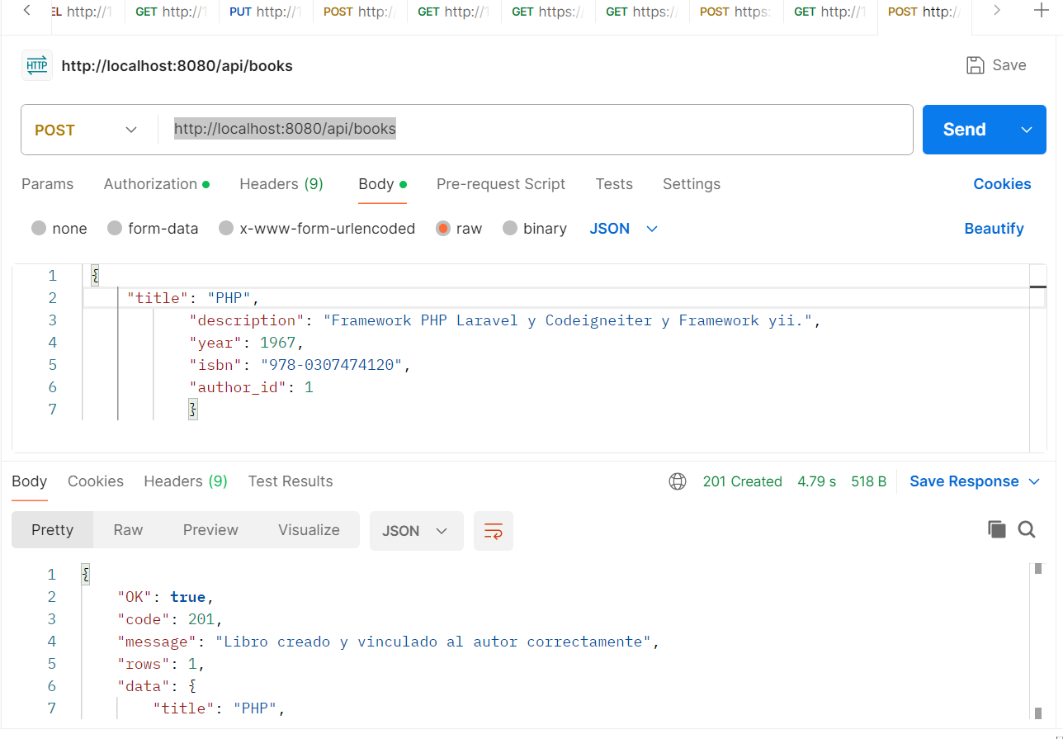

10.- PUT: http://localhost:8080/api/books/1

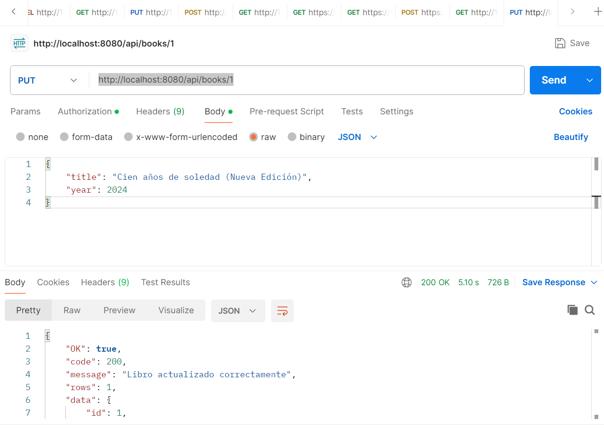

11.- DELETE: http://localhost:8080/api/books/2

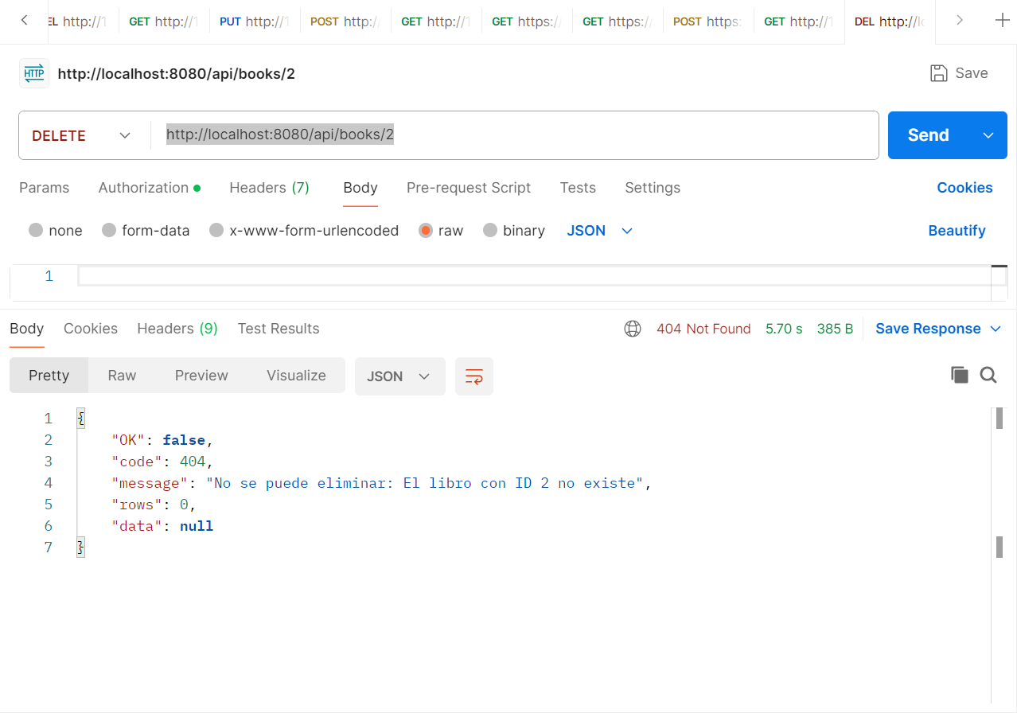

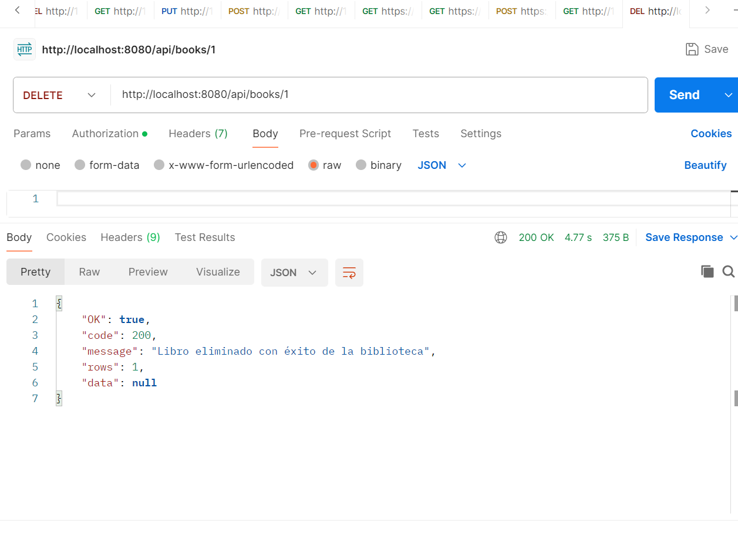

Validación NO Autorizado:

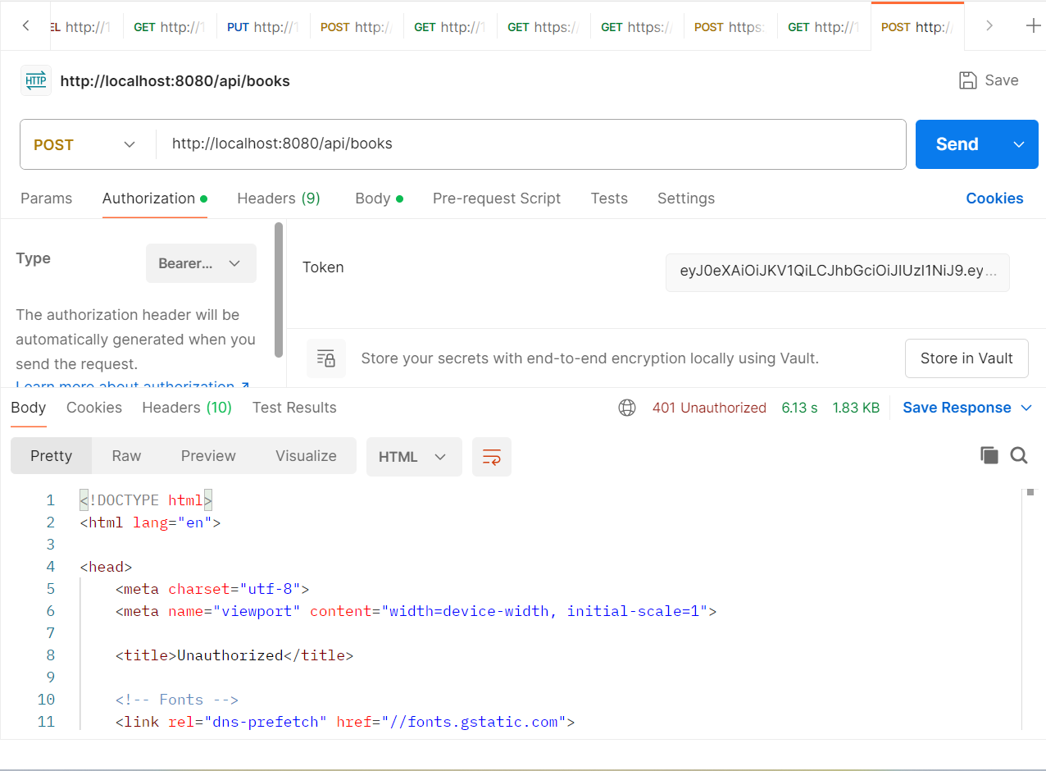

Prueba del Jobs ( BookObserver, Worker )
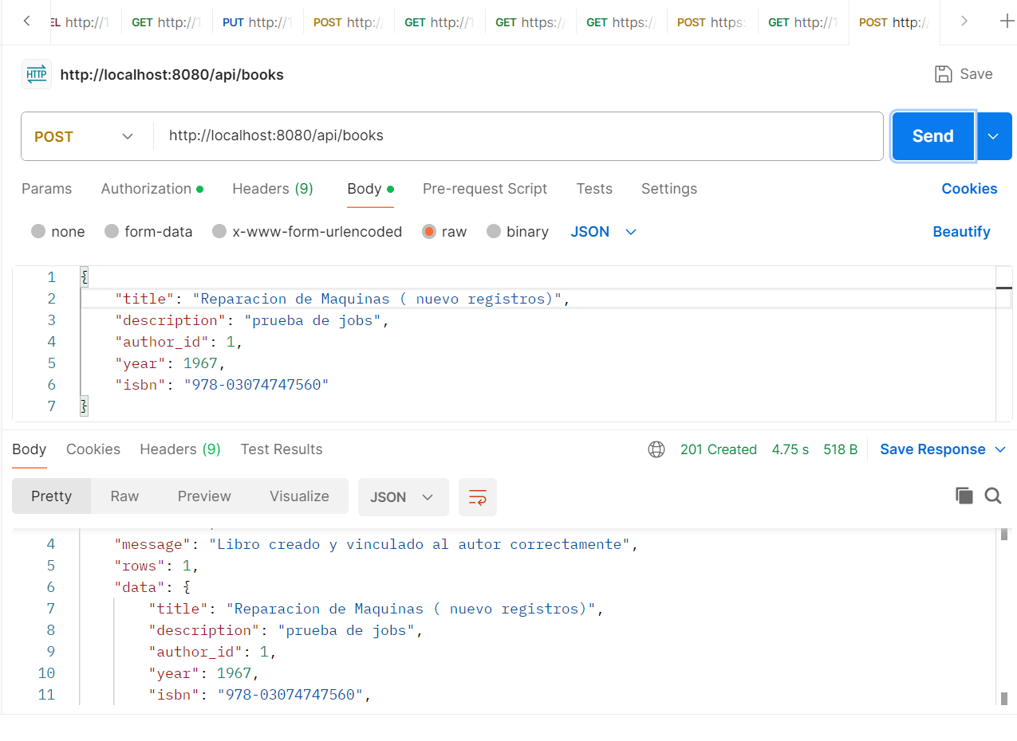

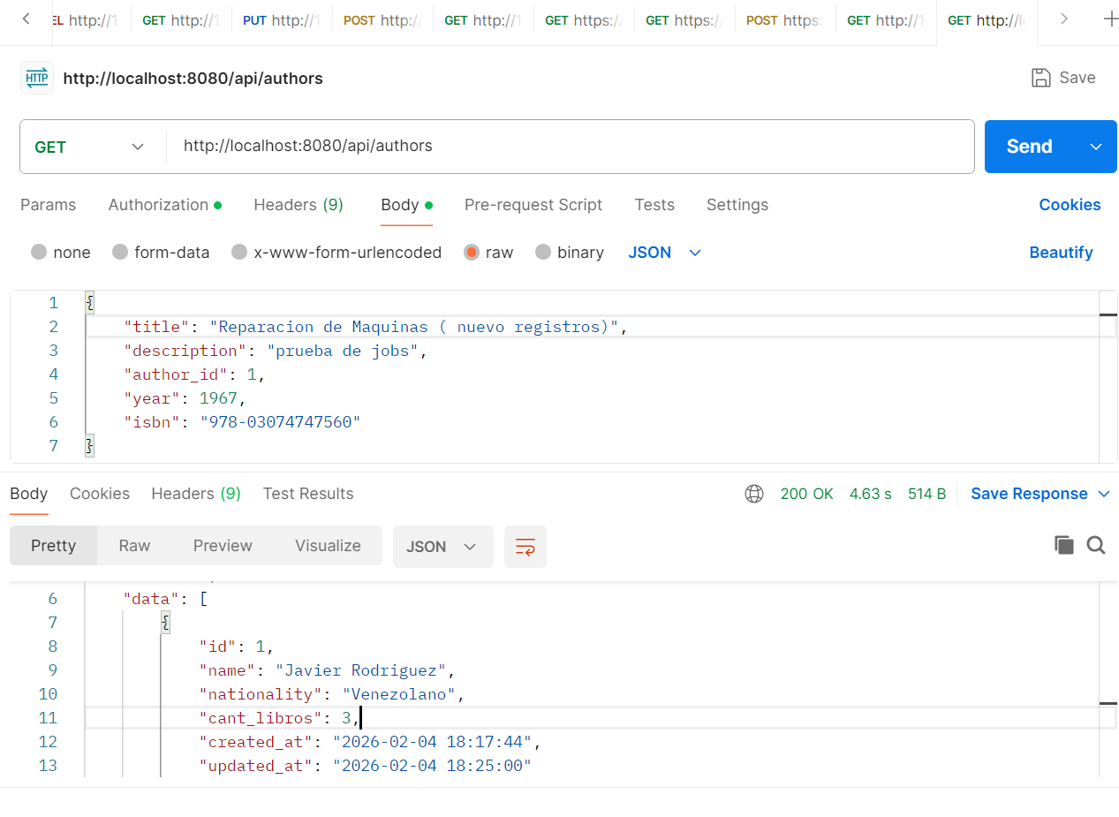

Estructura de la base de datos en MySQL y/o PostGresSQL

AUTORES
========================================================================
CREATE TABLE authors (
id BIGSERIAL PRIMARY KEY,
name VARCHAR(255) NOT NULL,
nationality VARCHAR(255) NULL,
cant_libros INTEGER DEFAULT 0, -- Campo actualizado por el Job
created_at TIMESTAMP(0) WITHOUT TIME ZONE NULL,
updated_at TIMESTAMP(0) WITHOUT TIME ZONE NULL
);

Libros
=============================================================================
CREATE TABLE books (
id BIGSERIAL PRIMARY KEY,
author_id BIGINT NOT NULL,
title VARCHAR(255) NOT NULL,
description TEXT NULL,
year INTEGER NULL,
isbn VARCHAR(255) UNIQUE NOT NULL,
created_at TIMESTAMP(0) WITHOUT TIME ZONE NULL,
updated_at TIMESTAMP(0) WITHOUT TIME ZONE NULL,

-- Relación de llave foránea
CONSTRAINT fk_book_author
FOREIGN KEY (author_id)
REFERENCES authors(id)
ON DELETE CASCADE
);

